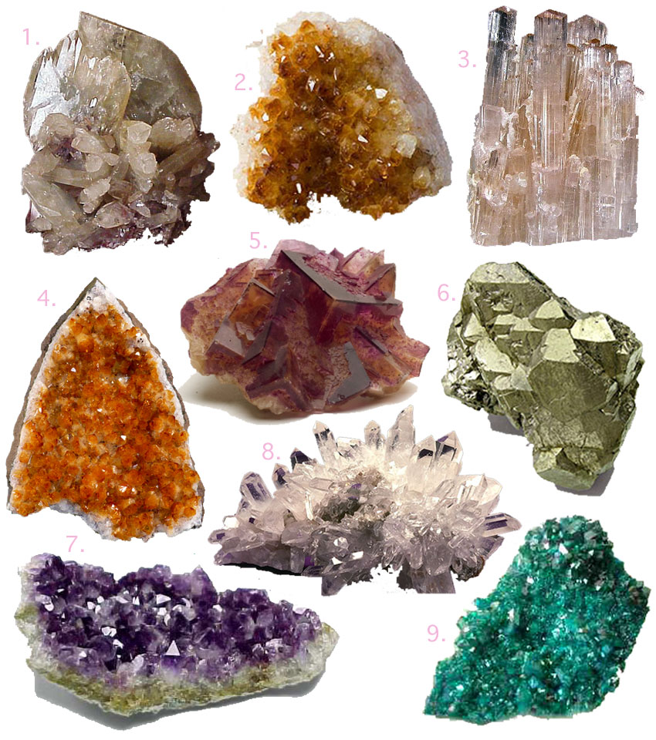
Observing Minerals

Mineral | Hardness | Lustre | Colour | Streak

